All Japan Round Dance Convention 33 in Numazu
JAPAN ROUND DANCE ASSOCIATION presents
March 9, 12:00 pm – March 11, 12:30 pm, 2018
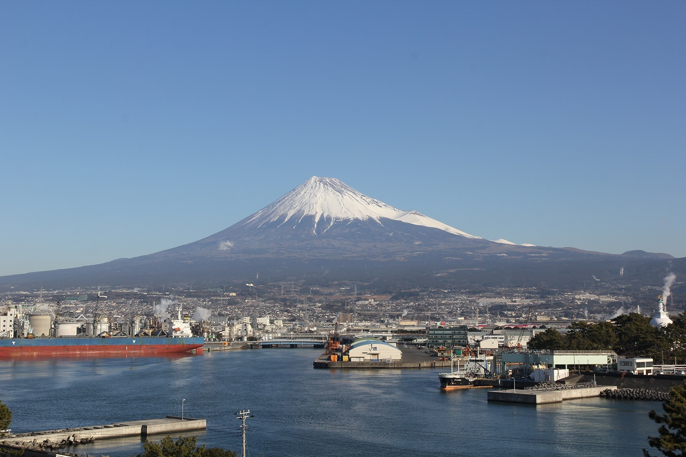
❉Dance Teaches Phase 3 thru 6,
❉Clinic Phase 3 thru 6,
❉ Party Dancing

Plaza Verde, Numazu
1-1-4 Otemachi, Numazu city, Shizuoka 410-0801 Phone: 81-55-920-4100
《Access》 3minutes walk from JR Numazu station
2.5 hours by Bus from Shinjuku, Tokyo Bus terminal
《Capacity》 450 people
《Registration Fee》 Japanese Yen 18,000 per person including 1 Dinner and 1 Lunch
《Hotel Booking》 Please contact the secretariat. It will arrange a nearby hotel for you.
《Registration》 Please fill in the application form below and e-mail it to the JRDA secretariat
JRDA Secretariat: jrdajimukyoku@hb.tp1.jp
《Application period》December 1, 2017~ January 31, 2018
❉ After completing participation, we will send guidance for registration fee payment for each couples. After confirming payment, we will send you an acceptance slip. Please make payment by 9th February.
《General Chair》 Kayoko Noguchi,E-mail: kayo.n.zz@lion.ocn.ne.jp
《Assistant Registration for Overseas》 Kenji & Nobuko Shibata, E-mail: kenjinobuko@gmail.com

《Video》 Video taking is prohibited.

33rd All Japan Round Dance Convention in Numazu Registration Form
Date of Registration: date month year
Name/Sex |  | M |  |  | M
 |  | F |  |  | F
Country
Address
Telephone
Email
Extra Syllabus | (JPY500) |  | (JPY500)
 | *Those who applied for it will be accepted at the reception desk
Figure Clinic  Choose Rhythm | □ WCS ， □ SB  *For those who are interested in “Figure clinic” |  |  |  |  |  | (JPY500)

